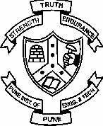College of Engineering, Pune

**(An Autonomous Institute of Government of Maharashtra)**

Applied Science Department

Tel: 020-25507034 Fax: 020-25507219

**CT16002 – Biology for Engineers**

**UNIT II: Levels of Organization of Life**

-----------------------------------------------------------------------------------------------

Cell as basic unit of life, prokaryotic and eukaryotic cells, microbes, plant and animal cells; Cell organelles – structure and function; Levels of organization of life - tissues, organs, systems and organism.

**LEVELS OF ORGANIZATION OF LIFE**

Cell as basic unit of life, prokaryotic and eukaryotic cells, microbes, plant and animal cells;

# CELL ORGANELLES

Present in all eukaryotic cells. Absent in prokaryotic cells, secondarily lost in mammalian RBC.

# MITOCHONDRION

Also called as power houses, energy coins. Present in all eukaryotic cells, except mammalian RBC where secondarily lost.

No. per cell variable, 1 in primitive eukaryotes, 5,00,000 insect flight muscles. Size 1.5—10 μm in length, 0.25 μm in diameter.

Shape cylindrical common, may be spherical, tubular, branched, discoidal.

# Ultrastructure : --

1. 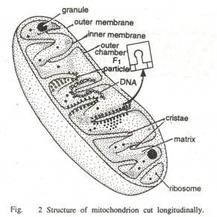2 membranes : **Outer** – limiting, permeable, smooth, **Inner** – selectively permeable thrown into folds called cristae / trabeculae.
2. In between two membranes peri – mitochondrial space, filled with homogenous fluid called cytosol, contains H 2O, minerals.
3. Inner mitochondrial cavity has dense, homogenous gel like matrix with high conc. of soluble proteins, nucleotides, lipids, circular DNA called mitochondrial/ mt DNA, ribosomes of 70s type, K+, HPO4, Mg++, Mn++, Cl—, SO4—, RNA (3 types), riboflavin vitamin.
4. Inner cavity divided into many compartments due to cristae, which are more in active cells. Inner membrane has 2 faces, outer face called C/ cytosl face, inner M/ matrix face. On inner surface of inner membrane i.e. at M face, numerous knob like elementary particles / F1 paticles / oxysomes / Fernandez – Moran sub-units.

Oxysome :- composed of base, stalk, head piece.

Head piece – contains F1 – subunit, spherical, contains enzyme ATPase / ATP synthatase Function – oxidative phosphorylation, oxidation of food, ATP release.

Base – contains Fo – particle / subunit , rectangular ,embedded in inner mitochondrial membrane, contains coezymes of ETC.

Stalk – contains F5, F6 subunit.

Mitochondria:- self duplicating, New one formed by division of existing one.

# Semi autonomous organelle –

Mitochondria – have own genetic information, in mitochondria DNA is independent of cell’s nuclear DNA., capable of self replication, capable of forming 3 types of RNA. Mitochondria has its own ribosomes. Hence can, form its own structural proteins. Few sub-units of mitochondria & enzymes are formed by itself from ribosomes. Remaining sub-units from cytosol. Hence mitochondrion is a semi autonomous organelle.

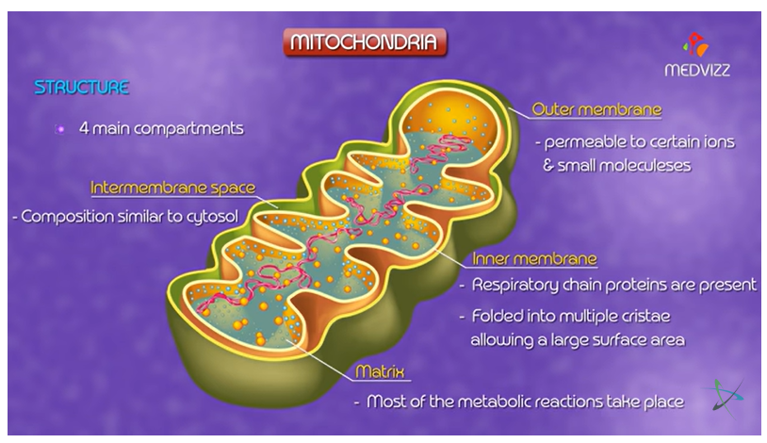

# Functions:-

1. Power house / storage batteries / ATP mills of cells.
2. Bring about oxidation of carbohydrates, fats., proteins.
3. Capable of self – replication.
4. Site for synthesis of haemoglobin( protein in blood), myoglobin ( protein in muscles).
5. Site for thermiogenesis (heat production).

**PLASTIDS – FOOD FACTORIES & STORE HOUSES**

On the basis of colour pigments plastids are classified in to chloroplasts (green), chromoplast (Yellow, orange etc.) and amyloplasts (White)

**Chloroplast** : Present in green parts of plant like leaves, skin of raw fruits, flower in bud condition, young stem.

**Shape** – Cup shaped, Spiral ,Girdle,Branched,Starlike ,Reticul ate, Spherical, Oval, Discoidal in higher plants. **Number** –1 to several hundreds. Size – 4 – 6 m.

# Ultra structure –

1. Covered by 2 membranes. Outer one permeable with less proteins. Inner one semi permeable with more proteins.
2. Periplastidial space of 25 – 75 A between 2 membranes.
3. Matrix / stroma **–** Ground substance, colourless, granular with proteins, lipids, 70 s ribosomes, circular DNA, (called as chloroplast/ ct – DNA), RNA (3types), enzymes.
4. In stroma no. of membranous sheets called lamellae. Lamellae form closed oval sacs called thylakoids.
5. Each thylakoid has intra thylakoid space / loculus. In loculus no. of para crystalline rounded bodies called quantosomes present which trap quantum of light. Each quantosome contains 230 chlorophyll pigment molecules. In higher plants quantosomes contain chlorophyll a & b, carotene, xanthopyll. Thylakoids also contain various electron carriers like cytochrome f, b, ferredoxin, plastocyanin, plastoquinone.

In eukaryotes – thylakoids are superi mposed like a pile of coins and form granum. In each granum 10 – 100 (average 20 – 50) thylakoids. In each chloroplast about 40 – 60 grana . Adjacent grana interconnected by stroma lamellae / frets / intergranal lamellae.

# Semi – autonomous organelles

Circular DNA, 70 S ribosome, RNA (3 types) present, hence can form another chloroplast using some enzymes from cytoplasm.

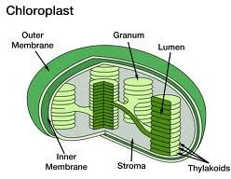

**Functions**-

1. Photosynthesis.

2. O2 replenished in atmosphere. 3.Starch storage.

4.Natural greenery

# Endoplasmic Reticulum – (ER)

ER has inter connected membrane bound vacuoles / cavities , concentrated in endoplasmic portion of cytoplasm (Cytoplasm has 2 regions – outer homogenous--ectoplasm, inner granular – endoplasm ), hence called ER,

# Occurrence –

Well developed in fully differ entiated, metabolically active eukaryotic cells – e.g. liver, pancreas. Absent in prokaryotic cells, secondarily lost in matured mammalian erythrocytes (RBC).

**Ultra structure** –Composed of 3 shapes

1. Cisternae – Near nucleus. Long, flattened, saclike, un branched tubules. Lie one upon the other, interconnected & studded with ribosomes.
2. Vesicles – oval / rounded, vacuolar structures, scattered in cytoplasm.
3. Tubules – branched, form reticular structure along with cisternae and vesicles. Near cell membrane. .

# Types:-

1. **Agranular / Smooth ER – SER** Ribosomes absent on outer membrane. Present near cell membrane. Generally in the form of tubules.
2. **Granular / Rough ER / RER –** Ribosomes attached to outer membrane. Generally in the form of cisternae. **Functions of Endoplasmic Reticulum –**
3. Fluid filled vacuolar system. Acts as endoskeleton; gives support to colloidal protoplasm.
4. Active, passive transport of material.
5. Divides cytoplasm into many compartments, thus cell activities take place separately in each compartment. Various organelles remain stationed.
6. Increase surface area for absorption / chemical reactions within cell.
7. Contain variety of enzymes.

# Golgi Complex: Molecular sorting & finishing area Ultrastructure -

Present in three shapes / forms --

1. Cisternae **-** Flat / curved , piled up one above other, with swollen ends. Outer convex surface associated with nuclear membrane/ ER. It is called – forming / cis / entry face Inner concave surface, called maturing / trans / exit face.
2. Vacuoles –Formed by fusion of small vesicles / large parts of broken cisternae. Generally associated near concave surface.
3. Vesicles – Pinched off from edges of cisternae hence near edges / concave surface. Chemical composition – Proteins – 60%, Phospholipids – 40% , Enzymes.

Origin – mostly from SER as cisternae connected to E.R.

# Functions –

1. Secretion – Mainly secretion of enzymes, hormones, glycoprotein, Ab( antibody).
2. Storage and Synthesis – Store proteins, lipids in the form of glycoprotein & glycolipid.
3. Packing and forwarding center for enzymes, mucus, hormones in small vesicles.
4. Cell plate formation in cell division.
5. Formation of primary lysosomes – Hydrolytic enzymes are formed in ER, then come to cisternae, packed and budde d off as primary lysosome.

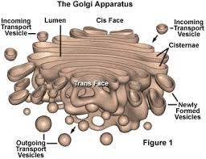

# Lysosomes : Sacs of hydrolytic enzymes

**Structure –** These are small membrane bound (unit membrane) vesicles. Contain hydrolytic enzymes.

*** Hydrolytic enzymes are stored in crystalline / fluid form. Membrane of lysosome is impermeable to enzyme. But ruptures during O 2 deficiency / exposure to poisonous substances. Then enzymes are released and cell itself is destroyed. Hence lysosomes are also known as suicidal bags of cells.***

# Types of Lysosomes

* 1. Primary lysosome - / sto rage granules – Derived from G.C. Contain only hydrolytic enzymes in inactive form. In the form of small vesicles.
  2. Secondary lysosome / Digestive vacuoles / Heterophagosomes – Pinosome ( vacuole with liquid) / phagosome (vacuole with solid) fuse with primary lysosome. Hence contain enzyme + material to be digested.
  3. Residual Bodies / Tertiary lysosome / Telolysosome – Undigested mateial remain in. Now called residual body . Come near plasma membrane, throw out their contents out side thro’ ephagy / exocytosis. If contents not discharged, the cells are loaded with it, cause nephritis, hepatitis, arthritis, gout, lung fibrosis.
  4. Autophagosomes / Autolysosomes **–** Cell organelles like ER, Mitochondria get worn out. Its degradation by lysosome called as autophagy. Primary lysosome + worn out cell organelle form autophagosomes.

# Function –

* + 1. Digestion – by hydrolytic enzymes.

Extracellular – enzymes are released in surrounding medium by exocytosis. Intracellular – by formation of secondary lysosomes or autophagosomes. E.g.

phagocytes in higher animals, degeneration of tail in tadpole larva of frog by enzyme cathepsin.

Heterophagy – digestion of foreign substance,

Autophagy – digestion of self substances. Thus lysosomes are self disposal units, also bring about physiological rejuvenation. Digestion of reserve food during starvation is also called as Autophagy.

* + 1. Initiate cell division by removing repressors of this process.
    2. By breaking thyroglobulins, thyroid hormone(thyroxin) is produced.
    3. In joint disorder like gout, arthritis -- macrophages come here & release lysosomes which causes inflammation.
    4. Accidental / pathological release of lysosome enzyme causes chrom osome breakage, abnormal distribution of chromosomes during mitosis, which may lead to blood cancer.

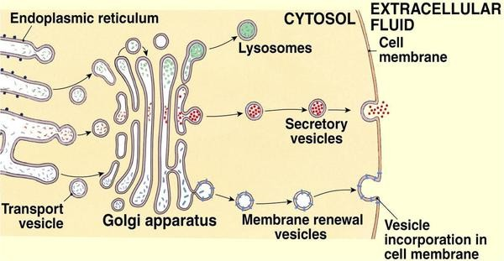

# Ribosomes: Work benches for protein analysis

**Occurance** -- both in pro and eukaryotic cells, except mature RBC.

**Types of Ribosomes** – According to size, sedimentation coefficient (S = 1  10-13 cm / sec

/ dyne / gm) 2 types.

1. 70 S ribosoms –found in mitochondria, chloroplast of eukaryotic & prokaryotic cells
2. 80 S ribosomes – “ in eukaryotic plant & animal cells.

**Structure** – Not covered by unit membrane, but porous, hydrated, 2 subunits. Larger & smaller. 70 S ribosome has 50 S and 30 S subunits & 80 S ribosome has 60 S and 40 S subunits which are separated by a narrow cleft. 2 subunits remain separated, join only

during protein syn thesis. In high conc. of Mg ++ ions  2 subunits remain united & called as dimmer. Smaller sub unit fits like a cap on larger subunit. Larger subunit – dome

– shaped, 2 binding sites Peptidyl / P site / donar site, Amino – acyl / A site / acceptor site. It has protuberance, ridge and stalk. Smaller subunit – ellipsoidal shape, cap like. It has a platform, cleft, head & base.

Polyribosome / polysomes – It is chain of ribosomes as formed during protein synthesis on m-RNA.

# Functions –

1. Protein factories / engines of cell as site of protein synthesis.
2. Free ribosome produce non – secretary proteins like enzymes for intra cellular use (e.g. in muscle cells, skin cells)
3. Bound ribosome like present on RER synthesize secretory proteins e.g. enzymeA

After synthesis of proteins, proper folding of proteins is assisted by specific proteins

**chaperons** which also assist transport of proteins into organelles like mito chondria

# Nucleus: Genetic message centre Ultrastructure -

Contains nuclear membrane, nucleolus, nucleoplasm, chromatin Nuclear membrane / karyotheca / Nuclear envelop / Nucleolemma.

* It is an outer envelop
* Present in all eukaryotic and Absent during late cell division.
* Consists of 2 unit membrane, between them perinuclear space of 75 A .
* Outer membrane continuous with RER, studied with ribosomes on outer side.
* Nuclear openings or pores in it to maintain nucleo – cytoplasmic connection.
* Outer membrane called as ectokaryotheca, inner called as endokaryotheca.
* Each nuclear pore has cylindrical annulus with pore complex.
* Through pore complex movement of substances takes place.
* mRNA come out through them into cytoplasm.
* Dissociates during early cell division, reappears at end of cell division.

# Nucleous –

Appears spherical, dense, colloidal, no limiting membrane. No. 2 -- 5

Parts – i)Granular region -- protein granules ii)Fibrillar region – proteinaceous fibrils iii)Amorphous matrix – less dense called ‘pars amorpha’. iv)Chromatin fibres are perinucleolar and intranucleolar.

Nucleoplasm – nuclear sap / nucleoplasm / karyolymph.

Transparent., semi – solid, granular, acidophilic.Composed of – Nucleic acids, enzymes, minerals.

# Chromatin –

Hereditary part. Network of fibres. During cell division organizes as chromosome.

.Heterochromatin **–** Show thick regions, darkly staining where DNA is condensed. Lies near nuclear membrane. Contain late replicating genes. Inactive genetically.

**Euchromatin – Thin regions, less darkly staining, DNA loose, genetically active.** Chromatin thread composition – DNA, RNA, proteins (histones., non – histones.) **Functions --**

1. Contain hereditary material in the form of chromosomes
2. Transfer genetic characters from one generation to another
3. Control cell division
4. Control all physiological activities of the cell.

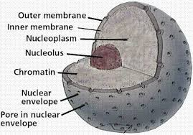

**EVOLUTION OF BIOLOGICAL MACHINES**

# Major changes that occurred when prokaryotes gave rise to eukaryotes -

* Cells acquired more DNA.
* DNA folded compactly into discrete complexes with specific proteins to divide it equally between daughter cells at cell division.
* Specialized proteins stabilize folded DNA (chromosomes).
* A system of intracellular membranes and a double membrane surrounding the DNA was developed.
* Early eukaryotic cells enveloped aerobic bacteria or photosynthetic bacteria to form endosymbiotic associations that became permanent. Some aerobic bacteria evolved into mitochondria of modern eukaryotes and some photosynthetic bacteria became plastids like chloroplasts and likely ancestors of modern plant cells.
* It was advantageous to cluster together for acquiring greater motility, efficiency, or reproductive success than their free -living, single -celled competitors.
* Specialization within the colony – to cellular differentiation.
* It led to even more complex and highly differentiated organisms, in which some of them carried out the sensory functions, others the digestive, photosynthetic or reproductive functions so forth.

# Principles of generating diverse body plans and design in nature :

The major events include the changes in

* 1. Size of organisms
  2. Form and complexity
  3. Expansions in diversity
  4. Production of many shapes of macroscopic life.

The evidences for the process of evolution are usually obtained from fossil records which is also the data at the time of origin.

# Inferences about direction of evolution:

1. Multicellularity evolved independently many times and in all parts of life i.e. plan ts, animals and microorganisms.
2. Multicellularity evolved from different unicellular ancestors.
3. These multicellular organisms have new body plans and physiologies
4. They represented more complex features.

These complex forms then diversified so that varied k inds appeared over a long period.

# Figure: Evolution of eukaryotes through endosymbiosis:

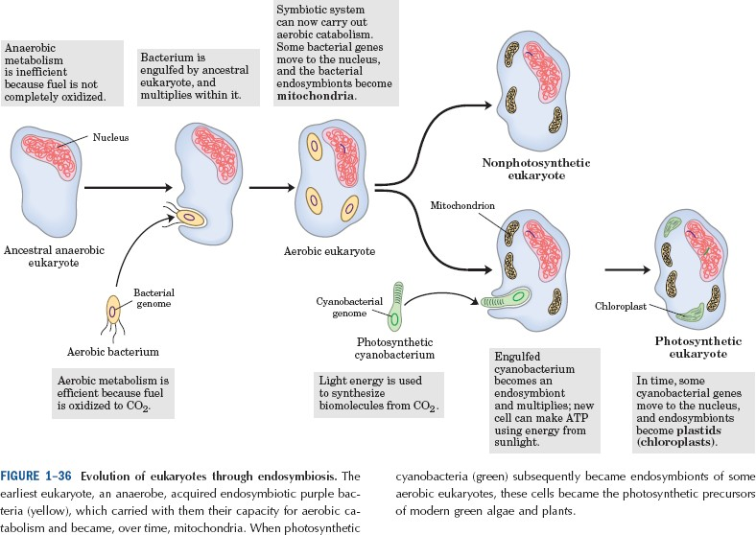

**Size and multicellularity:**

For first 2500 million years of life on the earth, most species w ere generally much smaller and rarely exceeded 1mm in size. The bacterial microfossils obtained from 3500 million years had 5mm diameter.

The early microfossils of eukaryotes were 40 -200 mm in size for first 600 -800 million years

# Cellular dimension are limited by oxygen diffusion:

A bacterial cell is 1 -2 mm long and animal/ plant cell is 5 -100 mm long. The upper limit of cell size is set by the rate of diffusion of solute molecules in aqueous system.

Consider the example of a bacterial cell -

It depends upon oxygen consuming reactions for energy production. So it has to obtain molecular oxygen by diffusion across its plasma membrane. The cell is small and the ratio of its surface area to its volume is large hence every part of its cytoplasm is easily receiving the diffused oxygen.

But as cell size increases, surface -to-volume ratio decreases. The rate of consumption of oxygen is faster than that of its diffusion because if the metabolism of the cell. So when the cell size goes on increasing, the oxygen dema nd for metabolism increases to such a point that the metabolism becomes impossible. This puts a theoretical upper limit for the cell size and cell cannot increase above this point.

Complexity: It is referred to as number of different cell types or the no./ functional specialization of parts.

# There are four types of complexity –

1. the number of different physical parts e.g. genes, cells, organs and organisms in a system..
2. the no. of different interactions between the above mentioned parts
3. the no. of levels
4. the no. of parts or interactions in a specific condition

**Diversity** : Actually the diversity of life has expanded from its origin but it doesn’t cause continuous increase. For the organisms those are made entirely of soft tissues or of small size, it cannot be said whether the total diversity increased or decreased over a long period of time.

# Levels of Organization

Within multi -cellular organisms there is division of labor . Division of labor means that the work (labor) of keeping the organism alive is divided (division) among the different parts

of the body. Each part has a job to do and as each part does its special job, it works in harmony with all the other parts.

The arrangement of specialized parts within a living thing is referred to as levels of organization.

# First Level :-Cells

Cells of course, are the first level of organization

# Second Level:- Tissues

Tissues are the second level of organization. In any multi -cellular organism, cells rarely work alone. Cells that are similar in structure and function are usually joined together to form tissues. There are four basic/ major types of tissues in the human body: Muscle tissue ( skeletal, smooth, cardiac muscles), nerve tissue ( brain, spinal nerves, cranial nerves), connective tissue ( bone, cartilage, blood), and epithelial tissue ( skin, other body parts coverings).

# Third Level :- Organs

Organs are the third level of organization.

When a bunch of different types of tissues work together, they form an organ . E.g. Brain, liver, stomach, heart etc.

# Fourth Level :- Organ System

Organ systems are the fourth level of organization.

Each organ in human body is a part of an organ system, a group of organs that work together to perform a major function. E.g. heart, blood vessels are parts of circulatory system, likewise digestive, excretory, respiratory systems.

# Fifth Level :- Organism/ Individual

Organisms with many systems form fifth level of organization.

# Single cell to multi cellular organism

* + Unicellular organisms formed colonies by remaining together after each cell division.
  + Division of labor, made it possible to exploit resources in better way.
  + For formation of multicellular organism, cells remain bound together. In animals extracellular organic matrix binds cells together as cell wall, plasmodesmata are absent.
  + Such fundamental arrangement is seen in epithelial tissue sheets.
  + From a group of cells, some cells differentiated from others and adopt different structure, chemistry, function usually in response to cues from neighbouring cells.
  + Cells have memory i.e. cell and its progeny usually persist in their differently specialized state even after disappearance of original stimuli.
  + Final character of animal not determined by its final environment but entire sequences of influences to which cells are exposed during development.
  + As body grows and mature s, progressively finer details of the adult body pattern become specified, complex organisms are formed in long developmental history.
  + Though more and more complex organisms are formed, early developmental stages very similar though adult stage radically different.
  + Specialization of cells depend on gene expression and not on loss or acquisition of genes. As specialization also involves loss of genetic material. E.g. RBC – lost nucleus during differentiation.
  + In eukaryotes sophisticated mechanisms for controlling gene expression has evolved.
  + Groups of genes activated or repressed in response to external and internal signals.
  + Radical differences of character between cell types reflect stable changes in gene expression.